# Calculating Beta using Co-variance (Final Step)

In this step, we finalize the calculation of beta (βP), which represents the portfolio's sensitivity to market movements.  
The beta is computed using the formula:  
  
 βP = Cov(RP, RB) / Var(RB)  
  
Where:  
- Cov(RP, RB) is the covariance between the portfolio and the benchmark market return.  
- Var(RB) is the variance of the benchmark market return.  
  
The portfolio beta indicates how much the portfolio's return changes in response to changes in the market return.

## Python Code

# Calculate the co-variance matrix between Portfolio_Excess and Market_Excess  
covariance_matrix = FamaFrenchData[['Portfolio_Excess', 'Market_Excess']].cov()  
  
# Extract the co-variance co-efficient  
covariance_coefficient = covariance_matrix.iloc[0, 1]  
print(covariance_coefficient)  
  
# Calculate the benchmark variance  
benchmark_variance = FamaFrenchData['Market_Excess'].var()  
print(benchmark_variance)  
  
# Calculating the portfolio market beta  
portfolio_beta = covariance_coefficient / benchmark_variance  
print(portfolio_beta)

## Screenshot

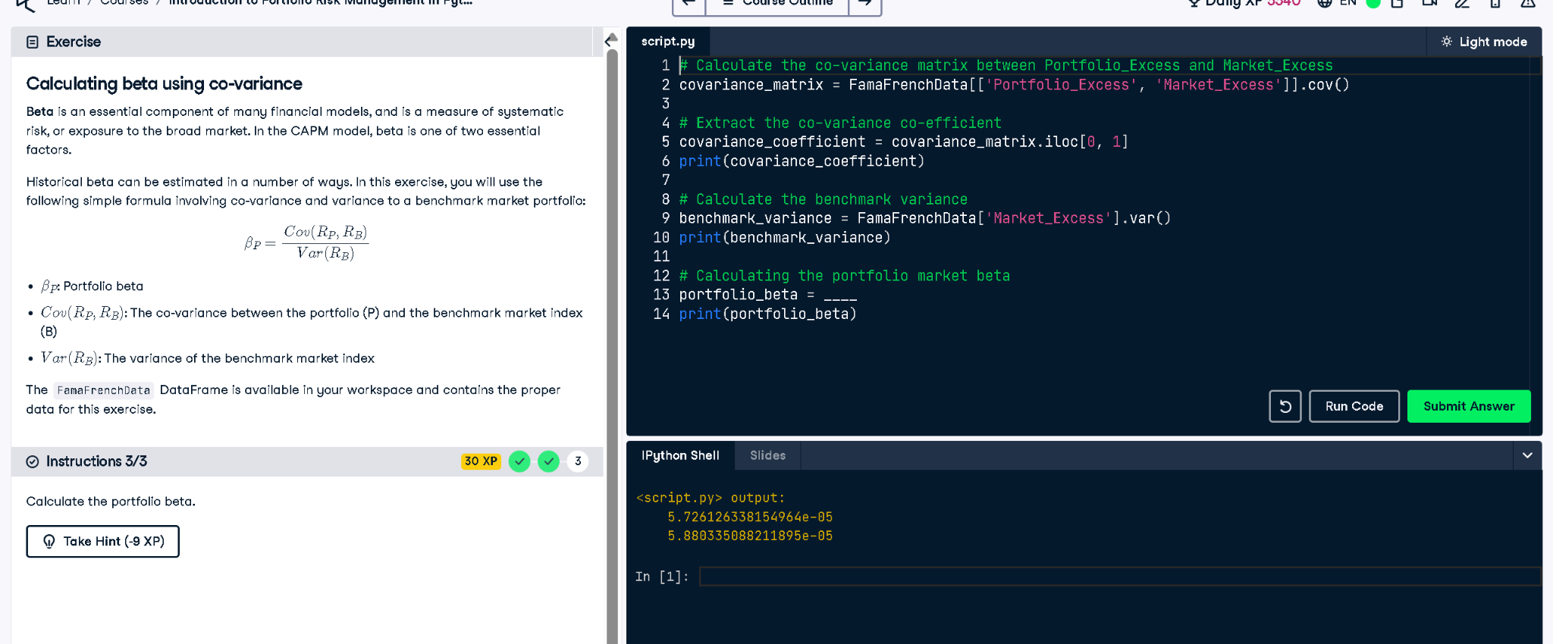

## Explanation in Simple Words

This code calculates beta, a number showing how much the portfolio follows the market's moves. It divides how much the portfolio and market move together (covariance) by how much the market changes on its own (variance).